Project Overview
This project analyses an SBA loan portfolio to understand loan performance, borrower risk, bank performance, and trends over time.
Using MySQL, I analysed the dataset from different business perspectives, including sectors, states, employee categories, business types, loan terms, loan amounts, banks, and time periods.
The main focus was to understand where loan defaults and financial losses are higher, identify patterns among different types of borrowers, compare bank and sector performance, and study how lending activity and portfolio performance changed over time.
I also created derived metrics such as Default Rate, Loss Rate, and SBA Coverage categories, and used these metrics to build comparisons, rankings, scorecards, and borrower personas.
Main areas covered
- Portfolio Performance loan volume, loan amounts, default and loss rates
- Borrower Risk Analysis sector, employee category, business type, loan term and loan size
- Bank Performance comparing banks using loan volume, default rate and loss rate
- Sector & State Analysis identifying higher- and lower-performing areas
- Customer Persona Analysis combining borrower characteristics to identify higher- and lower-risk groups
- Time & Date Analysis changes in lending, defaults, losses and SBA guarantees over time
- Financial Crisis Analysis comparing portfolio performance before, during and after the 2008
Overall objective: to move beyond simply querying the data and use SQL analysis to identify meaningful patterns, understand their business implications, and develop practical recommendations for managing loan portfolio risk.

Important Notes & Assumptions:
The following points should be considered while interpreting the findings and recommendations presented in this project.
1. Presence of "Unknown Industry"
A significant number of records belong to a sector labelled "Unknown Industry." During data exploration, I attempted to identify the actual industry by analysing other available fields such as industry codes and related attributes. However, the records were associated with multiple different codes and did not consistently map to a single industry.
Since these records also contain valuable information such as loan amounts, employee categories, business types, bank details, and state information, removing them from the dataset would have resulted in a substantial loss of data.
Therefore:
- "Unknown Industry" has been retained for overall portfolio analysis and calculations.
- For industry-specific insights and recommendations, it has been excluded where appropriate because it does not represent a clearly identifiable business sector.

2. Loan Amount Disbursed Greater Than Bank Approved Amount
The dataset contains a considerable number of records where the Loan Amount Disbursed exceeds the Bank Approved Amount.
Since these cases represent a meaningful portion of the dataset, removing them could introduce bias into the analysis.
The official dataset documentation does not explain why this occurs. One possible explanation is that additional funds may have been disbursed after the original loan approval, although this cannot be confirmed from the available data.
Therefore:
- These records have been retained throughout the analysis.
- Any explanation regarding the reason behind this difference should be considered an assumption rather than a verified fact.

3. Findings Represent Observed Relationships, Not Causation
The analyses presented in this project identify patterns and relationships within the dataset.
They should not be interpreted as proof that one factor directly causes another. For example, a higher default rate in a particular sector does not necessarily mean that operating in that sector alone causes defaults. Other business, economic, or borrower-related factors may also contribute.

4. Recommendations Are Based on the Available Dataset
The recommendations provided throughout this report are based solely on the information available in this dataset.
In a real-world banking environment, lending decisions would typically consider additional information such as:
- Credit scores
- Borrower income
- Financial statements
- Collateral details
- Repayment history
- Economic conditions
- Internal lending policies
These variables were not available in the dataset and therefore were outside the scope of this analysis.

5. Thresholds Used During Analysis
Where appropriate, I used minimum record-count thresholds (for example, requiring at least 1,000 loans before comparing banks or customer segments).
This was done to reduce the impact of very small sample sizes, which could otherwise produce misleading default rates or rankings.

6. Project Scope
The project demonstrates an end-to-end Data Analytics workflow, including:
- Data cleaning and validation
- Exploratory data analysis
- SQL-based business analysis
- Risk pattern analysis
- Business insights
- Reporting
- Dashboard-ready metrics
The project is intended as an analytical case study and should not be interpreted as an official assessment of any bank, business, industry, or lending institution.

7. Derived Features
Several categorical fields used throughout the analysis, such as Loan Category, Employee Category, Loan Term Category, SBA Coverage Category, and Business Type, were created during the data preparation phase to simplify analysis and improve interpretability.
These derived features were generated using transparent, rule-based categorisation and are intended to support business analysis rather than replace the original dataset values.

Introduction Ends here..

Key business insights
4. Key Business Insights & Recommendations
4.1 Portfolio Performance
Finding
The final dataset contains approximately 899,030 SBA loan records, representing approximately $180.9 billion in disbursed loan value and $173.2 billion in approved loan value. The portfolio has an observed 17.55% default rate, while the overall loss rate is approximately 7.02%. The average SBA guarantee percentage is 70.94%.
Insight
The portfolio is large in both volume and financial exposure, but the observed default rate indicates meaningful credit risk. Looking at loan volume alone would therefore provide an incomplete view of portfolio health. Both default frequency and financial loss need to be monitored alongside lending growth.
Recommendation
Management should monitor portfolio growth together with default rate, loss rate, charged-off principal and exposure concentration. Rapid growth in lending should be evaluated alongside changes in portfolio risk rather than treated as a standalone measure of performance.

4.2 Sector Risk & Financial Performance
Finding 1 Sector exposure
Retail Trade represents the largest identifiable sector by lending exposure, followed by sectors such as Manufacturing and Accommodation & Food Services. Unknown Industry was excluded from sector-specific comparisons because the underlying records could not be mapped consistently to a single identifiable sector.
Finding 2 Sector default risk
Several sectors show materially higher observed default rates than the overall portfolio. For example:
- Real Estate & Rental 28.68%
- Finance & Insurance 28.41%
- Transportation & Warehousing 26.43%
- Information 24.78%
- Educational Services 24.16%

Finding 3 Financial loss concentration
Retail Trade has the highest charged-off principal among the identifiable sectors, at approximately $2.05 billion, followed by Accommodation & Food Services at approximately $1.63 billion and Manufacturing at approximately $1.09 billion.
This is an important distinction:
A sector can have a high default rate without producing the highest absolute financial loss, while a high-volume sector can generate substantial losses even when its default rate is not the highest.
Recommendation
Banks should avoid using a single sector-level default rate as the sole approval criterion. Sector risk should be evaluated using default rate, loss rate, portfolio exposure and loan volume together.

4.3 Borrower Characteristics & Default Risk
Finding 1 Employee size
Default rates vary substantially across employee categories.
The Self-Employed category records the highest observed default rate at approximately 22.80%, while larger employee categories show substantially lower observed default rates.
Insight
Business size appears to be an important risk differentiator in the historical portfolio. However, this should be interpreted as an observed relationship rather than evidence that employee size itself causes default. Your assumptions section already correctly establishes this distinction.
Recommendation
Smaller businesses, particularly self-employed borrowers, could receive additional underwriting scrutiny, while avoiding automatic rejection based solely on employee count.

Finding 2 New vs Existing Businesses
- New: 18.74%
- Existing: 17.10%
- Unknown: 7.09%
Insight
New businesses have a higher observed default rate than existing businesses.
The difference is not enormous, but it provides evidence that business maturity may be a useful risk indicator when combined with other borrower characteristics.

Recommendation
For newer businesses, lenders could consider additional verification of financial capacity, business stability and repayment ability where such information is available.

4.4 SBA Coverage & Default Risk
Finding
Observed default rates by SBA Coverage Category are approximately:
- Low Coverage 29.49%
- High Coverage 17.26%
- Medium Coverage 11.33%
- Very High Coverage 0.92%
Insight
The data shows a clear difference in observed default rates across SBA coverage categories, with the lowest coverage category showing substantially higher default rates.
However, this should not be interpreted as proof that increasing SBA coverage causes lower defaults. Other characteristics may differ across these groups.
Recommendation
SBA coverage can be incorporated as one component of a broader risk assessment framework, alongside borrower size, business type, sector, loan amount and other underwriting information.

4.5 Loan Characteristics & Risk
Finding Loan term
Observed default rates differ significantly by loan term:
- Short Term 49.07%
- Medium Term 20.70%
- Long Term 7.02%
Insight
Short-term loans show a substantially higher observed default rate than medium- and long-term loans.
Short-term loans were associated with higher observed default rates in this dataset.

Finding Loan amount
Your Page 3 analysis also shows that default rates vary considerably across loan amount bands, with the smallest loan bands showing relatively high observed default rates.
This suggests that loan size alone should not be interpreted as a simple linear risk indicator.
Recommendation
Loan amount should be evaluated together with borrower characteristics and historical performance rather than using a single loan-size threshold for approval or decline.

4.6 Geographic Risk Analysis
Finding
The analysis identified meaningful variation in observed default rates across states. Eleven states exceeded the 20% default-rate threshold under the minimum-volume criteria used in the analysis.
California also represents the largest lending exposure among states, with approximately $35.2 billion in loan value in the SQL analysis.
Insight
Geography appears to be an important dimension for portfolio monitoring, but the results should not be interpreted as evidence that location alone causes default.
Recommendation
Banks should monitor state-level portfolios using:
- Default Rate
- Loan Volume
- Disbursed Exposure
- Charged-Off Principal
- SBA Coverage

4.7 Bank Performance Analysis
Finding
The analysis compared banks using loan volume, approved amount, default rate and loss rate, with minimum loan-count thresholds applied to reduce distortion from small portfolios.
Wells Fargo had the highest total approved amount in the analysed dataset, while Bank of America had the highest loan count among the leading banks.

Insight
High lending volume does not necessarily imply strong portfolio performance.
Therefore, bank performance should be assessed using both:
Scale + Risk
rather than loan count or approved amount alone.
Recommendation
Management should compare banks using a balanced scorecard incorporating:
Portfolio Scale → Default Rate → Loss Rate → Charged-Off Principal

4.8 Customer Persona Analysis
Business Type + Employee Category + Sector
to create borrower personas and identify higher- and lower-risk combinations. The existing SQL document records this analysis as Customer Persona Analysis.
Key finding
Examples of high-risk combinations included:
- Real Estate & Rental | Self-Employed 35.65%
- Finance & Insurance | Self-Employed 34.10%
- Information | Self-Employed 31.46%
- Transportation & Warehousing | 2–10 Employees 29.80%
- Construction | Self-Employed 29.20%
Insight
The results suggest that risk can vary substantially when multiple borrower characteristics are considered together.
This is more informative than looking at sector or employee size independently.
Recommendation
Lenders could use historical borrower profiles as an additional risk-screening layer, while combining them with financial and credit information that was unavailable in this dataset.

4.9 Portfolio Risk During the 2008 Period
Finding
The 2008 period recorded substantially higher observed risk than the surrounding periods:
Period | Default Rate | Loss Rate
Before 2008 | 17.18% | 6.73%
2008 period | 36.01% | 15.50%
After 2008 | 12.45% | 2.91%
The analysis also found that the average loan amount after the 2008 period was higher, at approximately $251,894, while observed default and loss rates were lower.
Insight
The results demonstrate that portfolio risk can change substantially during different economic periods. The findings also show that larger average loan size does not automatically imply higher observed default risk.
Recommendation
Historical portfolio monitoring should incorporate economic and time-period context rather than evaluating lending performance without considering the environment in which loans were originated.

5. Power BI Dashboard
5.1 Dashboard Overview
The Power BI dashboard was developed to convert the SQL analysis into an interactive decision-support environment. The dashboard allows users to examine portfolio performance across borrower characteristics, sectors, states, loan characteristics and time periods.
Dashboard Page 1 Portfolio Overview
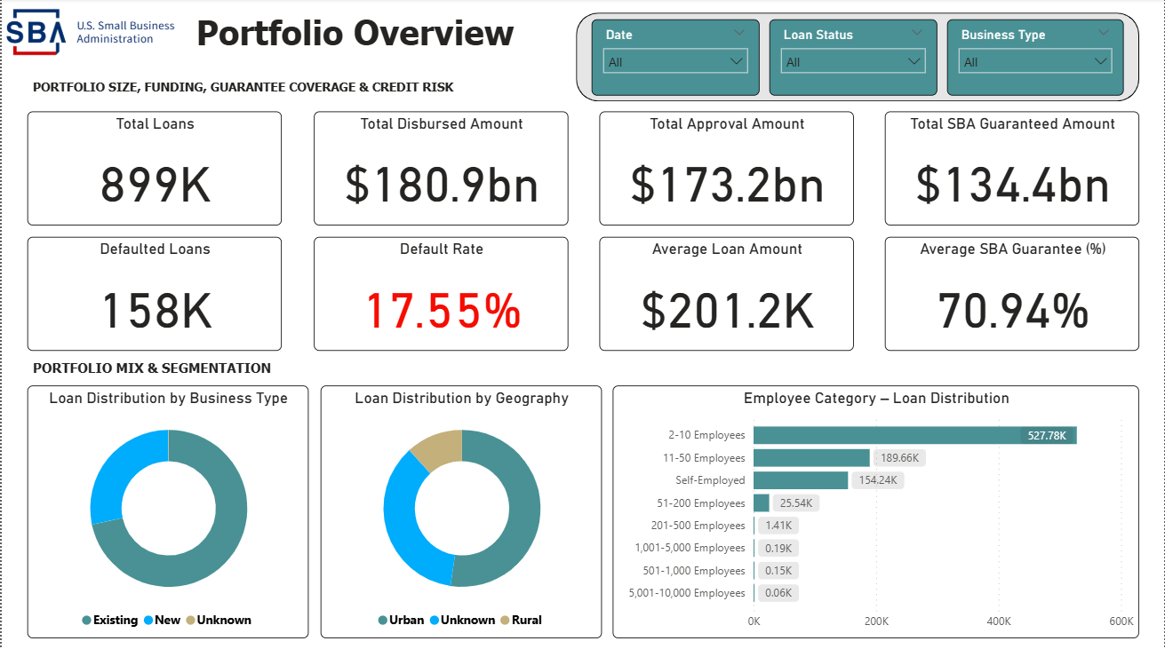
Focus:
- Portfolio size
- Disbursed and approved amounts
- SBA guaranteed amount
- Defaulted loans
- Default rate
- Average loan amount
- SBA guarantee percentage
- Business/geographic/employee mix
Business purpose: Provides management with a high-level view of portfolio scale, funding and credit performance.

Dashboard Page 2 Sector & Borrower Risk
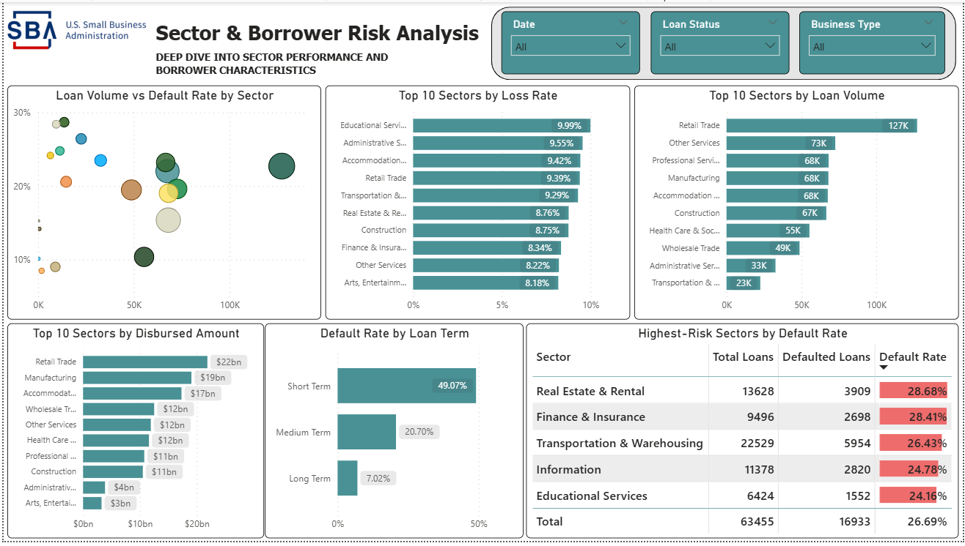
Focus:
- Sector loan volume
- Sector exposure
- Sector loss rate
- Sector default rate
- Loan-term risk
- Sector risk vs loan volume
Business purpose: Identifies sectors and loan characteristics associated with higher observed credit risk.

Dashboard Page 3 State & Geographic Loan Analysis
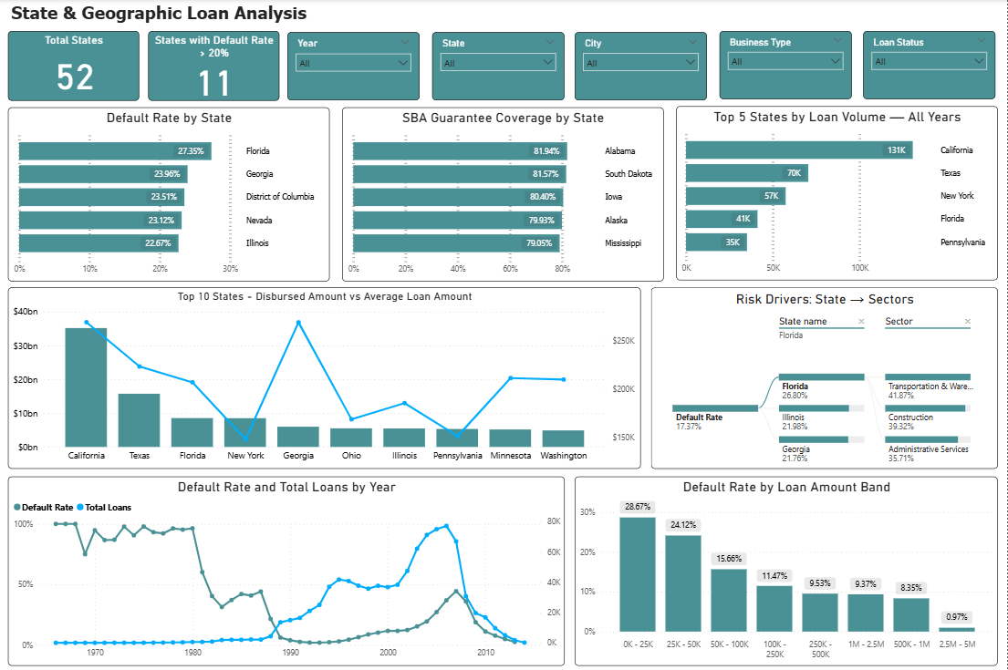
Focus:
- State default rates
- State loan volume
- State exposure
- SBA coverage by state
- State-sector risk drivers
- Loan amount risk
- Portfolio trends over time
Business purpose: Helps identify geographic concentrations and state-level risk patterns.

Dashboard Page 4 Loan & Borrower Risk Analysis
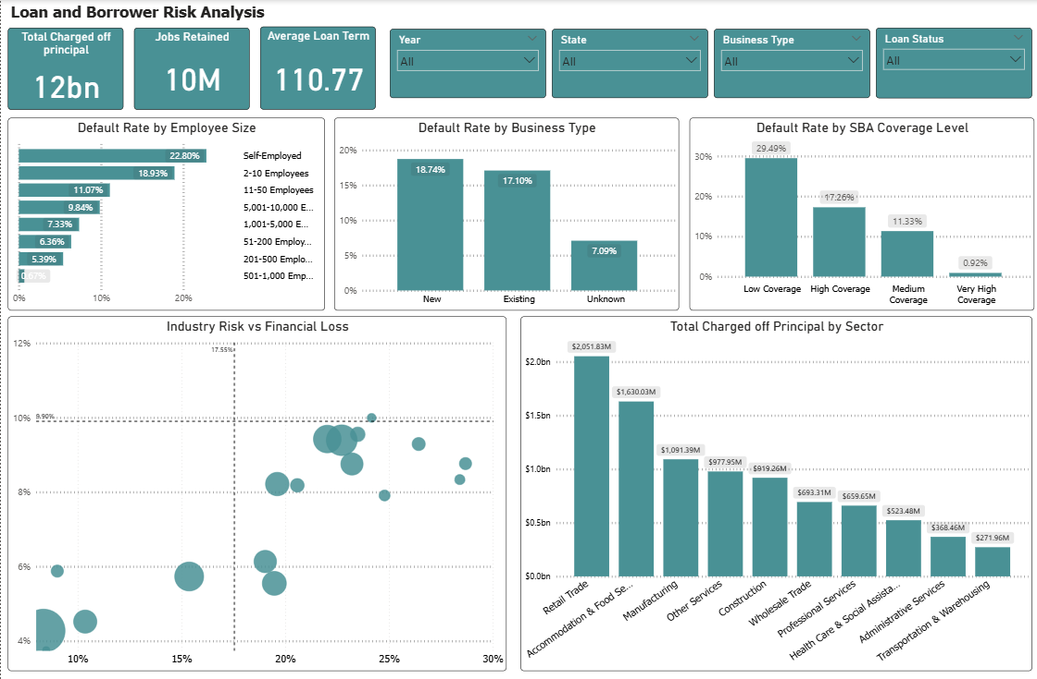
Focus:
- Employee-size default rates
- New vs Existing business risk
- SBA coverage risk
- Industry financial losses
- Industry risk vs financial loss
The Industry Risk vs Financial Loss scatter plot is particularly useful because it evaluates:
Default frequency + Loss severity + Portfolio exposure
simultaneously.
Business purpose: Supports a more targeted assessment of borrower and loan characteristics associated with historical risk.

6. Key Cross-Analysis Findings
6.1 High Default Does Not Always Mean Highest Financial Loss
Default rate measures frequency, while charged-off principal measures financial impact.
Therefore, lenders should evaluate both measures when prioritising risk.
6.2 Borrower Characteristics Interact
Employee size, business type and sector can produce materially different risk profiles when considered together.
This supports moving beyond one-dimensional borrower segmentation.
6.3 Portfolio Scale Can Hide Risk
Large states, sectors and banks may have high charged-off amounts simply because they manage larger portfolios.
Therefore:
Exposure should always be evaluated alongside rates.
6.4 SBA Coverage Shows a Strong Historical Relationship With Default
Lower SBA coverage categories show higher observed default rates in the analysed dataset.
However, this should be treated as an association rather than causation.
6.5 Economic Period Matters
The 2008 period showed substantially higher observed default and loss rates, demonstrating why historical lending performance should be evaluated in context.

7. Business Recommendations
Recommendation 1 Use Multi-Factor Risk Screening
Loan approval should not depend on a single variable such as sector, employee count or loan size.
Historical analysis suggests that risk varies across combinations of:
Sector + Business Type + Employee Size + Loan Characteristics + SBA Coverage

Recommendation 2 Apply Additional Review to High-Risk Borrower Profiles
Borrower profiles showing consistently high historical default rates should receive enhanced review rather than automatic rejection.
Examples include combinations involving:
- Self-employed borrowers
- Certain higher-risk sectors
- Smaller employee categories
- Lower SBA coverage

Recommendation 3 Monitor Financial Loss, Not Just Default Rate
A high default rate does not necessarily produce the largest financial loss.
Portfolio management should therefore track:
Default Rate + Loss Rate + Charged-Off Principal + Exposure

Recommendation 4 Monitor Geographic Concentration
States with both:
High loan exposure + high observed default/loss
should receive additional portfolio monitoring.

Recommendation 5 Use Economic Periods in Portfolio Monitoring
The large increase in observed default and loss during the 2008 period demonstrates the importance of considering broader economic conditions when interpreting historical performance.

Recommendation 6 Use Historical Risk Profiles as a Screening Layer
Customer personas can help identify borrower combinations that historically performed poorly.
However, these profiles should support not replace underwriting decisions.

8. Proposed Lending Risk Framework
The analysis suggests a three-level historical risk-screening framework:
Lower Historical Risk
Characteristics associated with relatively lower observed default/loss performance.
↓
Moderate Historical Risk
Mixed performance requiring additional review.
↓
Higher Historical Risk
Characteristics associated with consistently higher observed default and/or financial loss.
The framework represents a historical risk-screening approach derived from observed portfolio patterns. It is not intended to replace a formal credit underwriting model.

9. Limitations
Summarise the most important limitations:
- Unknown Industry records
- Disbursed amount exceeding approved amount
- Observational relationships rather than causation
- Missing credit/financial/collateral variables
- Minimum sample-size thresholds
- Derived categorical variables
- Historical dataset may not represent current lending conditions

10. Conclusion
This project demonstrates how a large SBA loan portfolio can be transformed from raw historical records into actionable credit-risk insights using SQL and Power BI. The analysis identified meaningful differences in observed default and loss performance across sectors, states, borrower sizes, business types, loan characteristics and economic periods.
The findings indicate that loan risk should not be evaluated using a single factor. Combining borrower characteristics, sector exposure, loan characteristics, SBA coverage and financial-loss measures provides a more comprehensive view of historical portfolio risk.
The Power BI dashboard converts these findings into an interactive decision-support tool, allowing stakeholders to move from portfolio-level performance to specific borrower, sector and geographic risk patterns.
While the analysis cannot replace a formal credit underwriting model due to the absence of variables such as credit scores, financial statements and collateral information, it provides a data-driven framework for identifying historical risk patterns and areas requiring additional review.
Overall, the project demonstrates an end-to-end analytical workflow from data preparation and SQL analysis to business interpretation, visualization and recommendations with the ultimate objective of supporting more informed portfolio risk management and lending decisions.

